Task 7
#include <stdio.h>

int main() {
int age;
float height;

printf("Enter your age: ");
scanf("%d", &age);

printf("Enter your height in meters: ");
scanf("%f", &height);

printf("You are %d years old and %.2f meters tall.\n", age, height);

return 0;
}
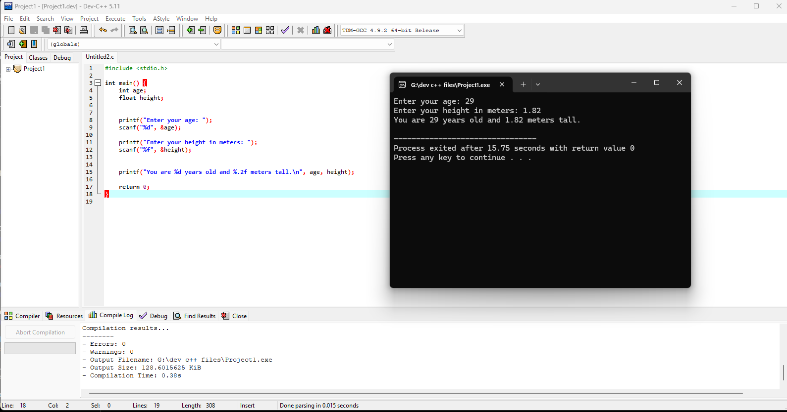

Task8
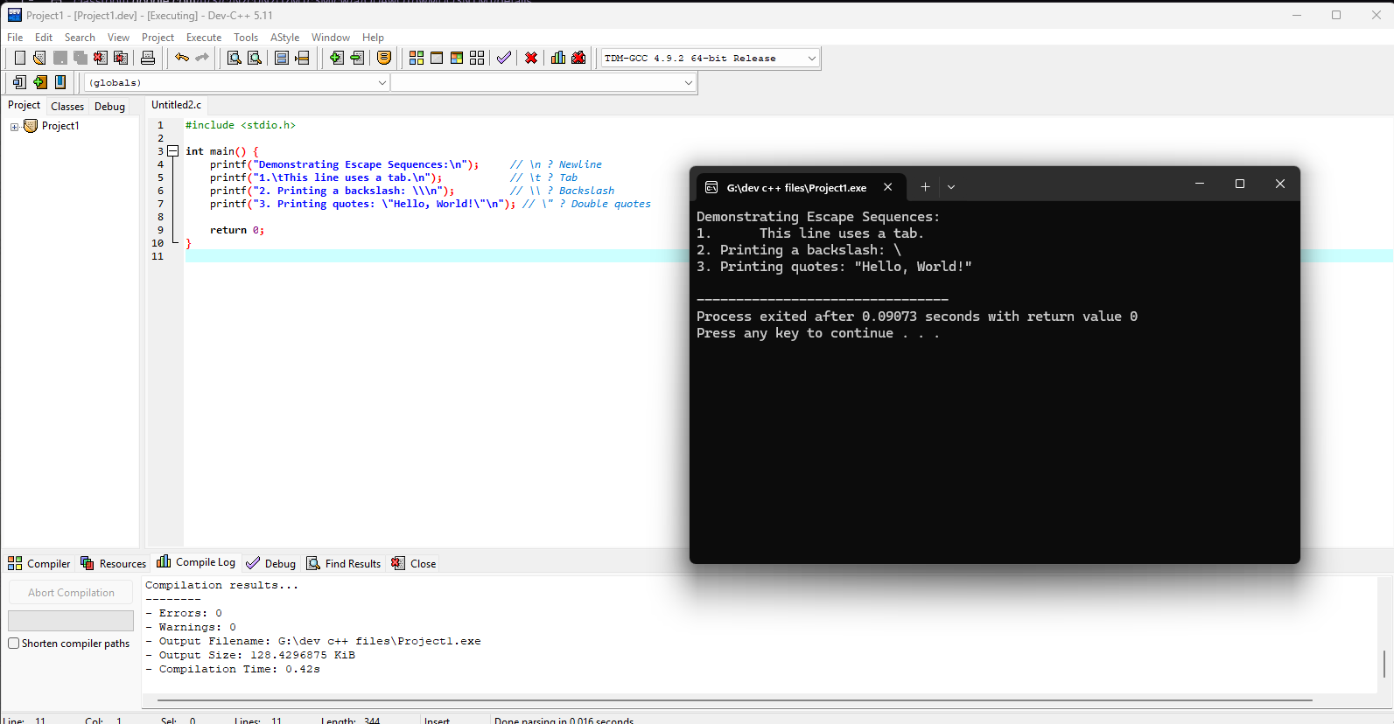
#include <stdio.h>

int main() {
printf("Demonstrating Escape Sequences:\n"); // \n ? Newline
printf("1.\tThis line uses a tab.\n"); // \t ? Tab
printf("2. Printing a backslash: \\\n"); // \\ ? Backslash
printf("3. Printing quotes: \"Hello, World!\"\n"); // \" ? Double quotes

return 0;
}
Task9
#include <stdio.h>

int main() {
int birthYear, currentYear, age;

printf("Enter your birth year: ");
scanf("%d", &birthYear);

printf("Enter the current year: ");
scanf("%d", &currentYear);

age = currentYear - birthYear;

printf("You are %d years old.\n", age);

return 0;
}
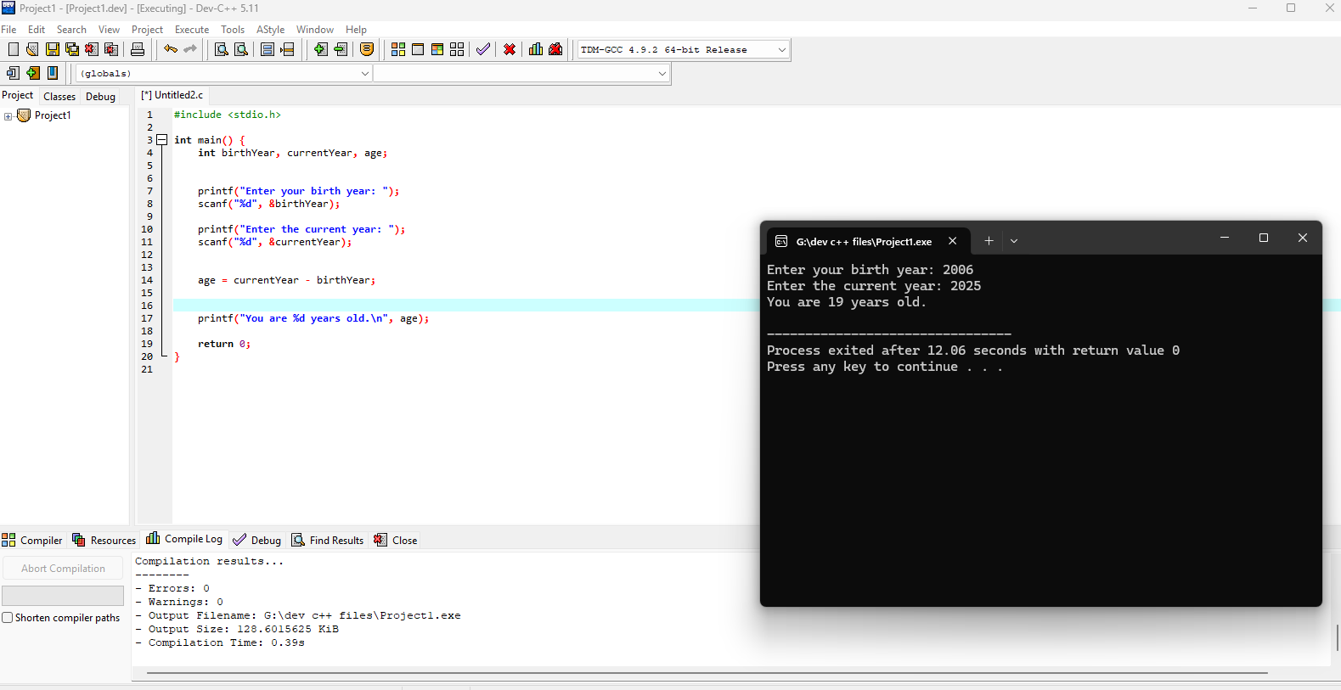
Task 10
#include <stdio.h>

int main() {
int age, months, days;

printf("Enter your age in years: ");
scanf("%d", &age);

// Convert age to months and days
months = age * 12;
days = age * 365; // ignoring leap years

printf("You are %d years old.\n", age);
printf("That is about %d months or %d days.\n", months, days);

return 0;
}
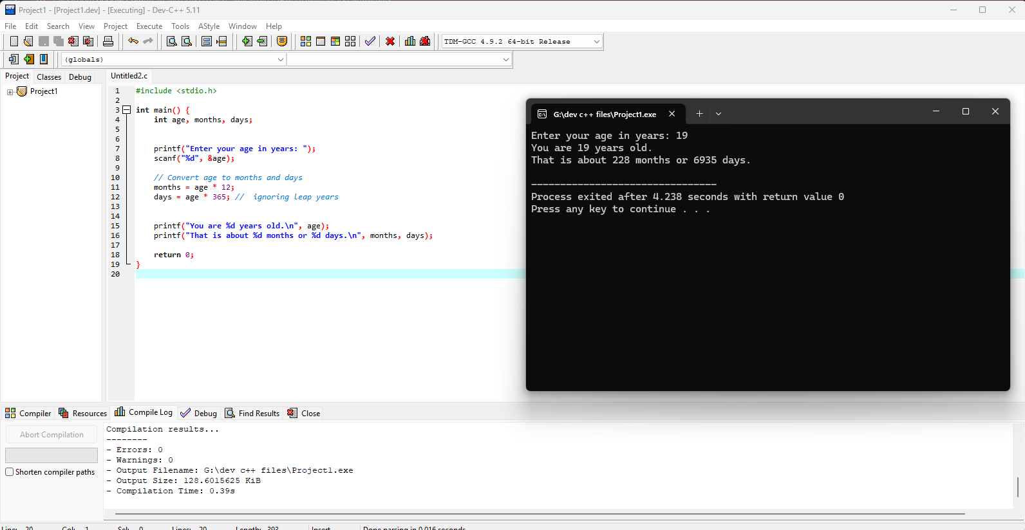

Task4
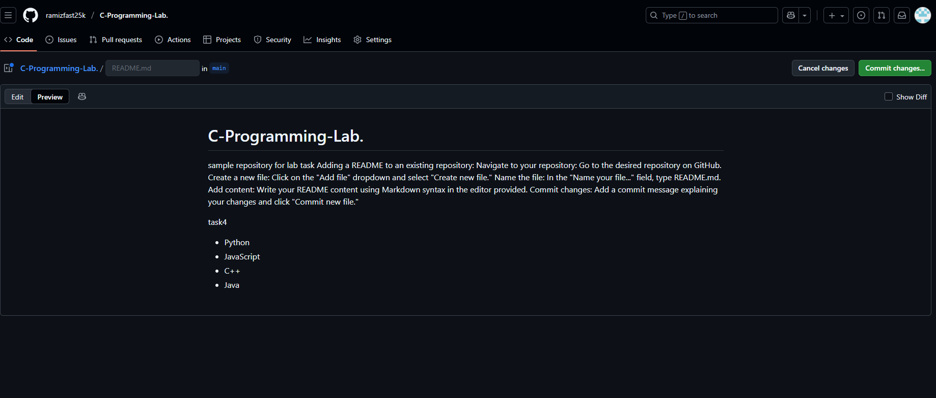

Task5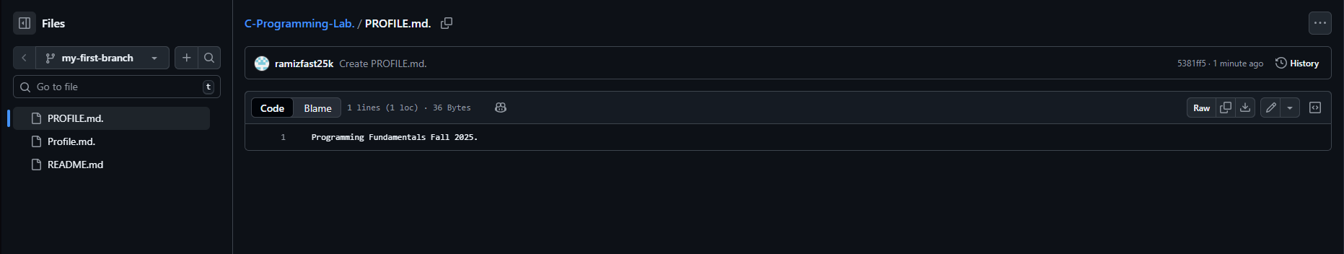

Task 6
